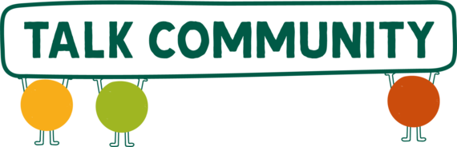
Newsletter
24 July 2025
UKSPF Grants Now Open: Apply Today for Community Transport or Sports Club Funding
Do you run a local group, community organisation or sports club in Herefordshire? Two new grant schemes are now open, funded through the UK Shared Prosperity Fund (UKSPF), offering support for projects that improve wellbeing, inclusion and local access.
The Community Transport Grant Scheme offers support to local transport projects that help people access services, reduce isolation and stay connected, especially in rural areas. Grants range from £500 to £5,000, with bursaries of up to £1,000 also available to help residents experiencing transport poverty.
The Sports Club Development Grant Scheme offers grants of £500 to £5,000 to support grassroots clubs and community groups that want to expand access to sport, grow participation, build volunteer capacity, and improve health and wellbeing across Herefordshire.
Both schemes are revenue-only and focused on making a real difference to people’s lives and community wellbeing. The deadline to apply is Friday 15 August 2025.
To apply, please visit the Herefordshire Council website. For queries, email: delegatedgrants@herefordshire.gov.uk or, to learn more about UKSPF, visit the Herefordshire Council website.

Funded by the UK Government through the UK Shared Prosperity Fund.
Love Parks Week 2025
Love Parks Week takes place 25th July – 3rd August and is an opportunity to celebrate the vital role green spaces play for communities across the UK.
In Herefordshire, we are blessed with an abundance of green spaces and parks. This Love Parks Week we are encouraging you to enjoy your favourite park or explore a new one! The Herefordshire Council website has a useful page where you can search for a park by postcode, or by park facilities (handy if you’re looking to explore something new!).
Over in Leominster, there’s FREE weekly park yoga taking place every Sunday until 14th September. Find out more on the Talk Community Directory. Another great way to enjoy your local green space is by joining a wellbeing walk. They’re free and friendly and a great way to get active and connect with your community! Visit the Ramblers website for more information.
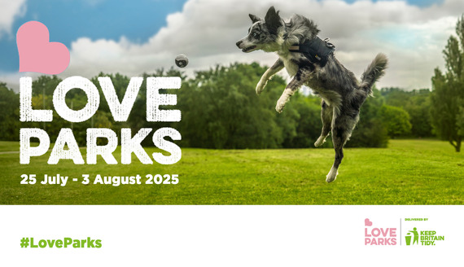
Community Matters Fund (Low Carbon Communities) – applications close on Friday 1st August
National Grid’s Electricity Distribution business, in partnership with LocalGiving, is offering grants to charitable organisations supporting communities working hard to improve their resilience in the energy transition.
The Fund can be used to support energy-efficient initiatives to lower carbon footprint, save energy costs and improve energy-efficiency ratings. These projects can be delivered in a building or within the wider community.
Applications close at 5pm Friday 1st August 2025. For more info and to apply visit the LocalGiving website.
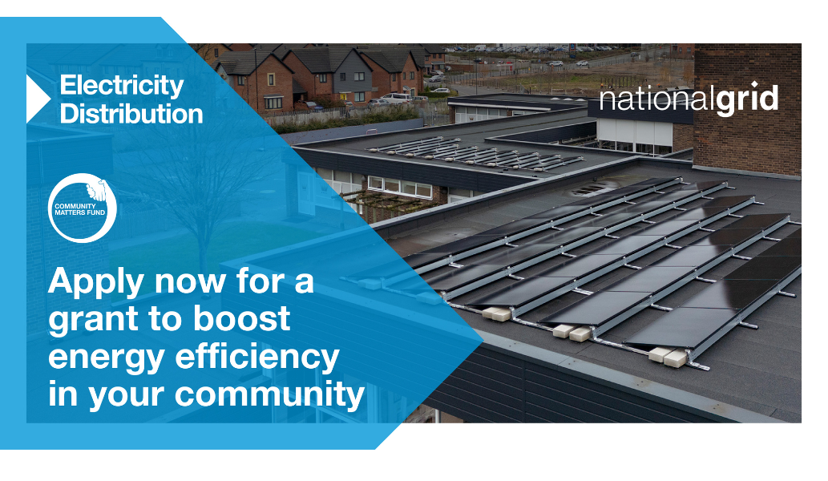
Herefordshire SEND Newsletter
The Herefordshire SEND Newsletter is co-produced by Herefordshire Council, Parent Carer Voice Herefordshire and Herefordshire Integrated Care System. The newsletter aims to provide easy access to key information and updates for families of children and young people with SEND (special educational needs and disabilities).
The latest newsletter is full of information about what’s happening across the county and includes details about providers offering SEND sessions over the holidays. You can read the latest newsletter online.
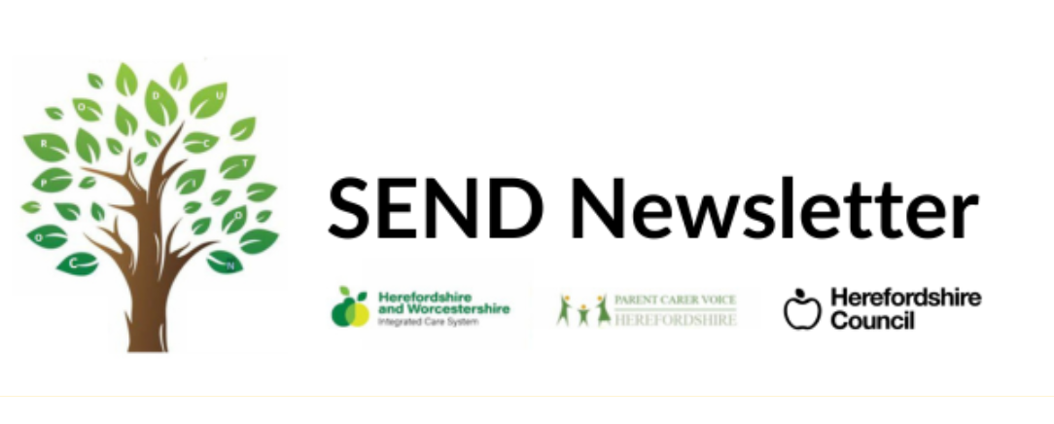
Volunteer Opportunity
The Wye Valley Trust is recruiting volunteers to join their Maternity team. If you have experience of breastfeeding and are interested in supporting new parents on their infant feeding journey then this could be for you. If you can commit to 1-2 hours per week and you are interested in finding out more, please contact the team by emailing Infantfeeding@wvt.nhs.uk
A drop-in information session for anyone interested in volunteering will take place at Widemarsh Children’s Centre on Thursday 25th September 1pm-2.30pm.
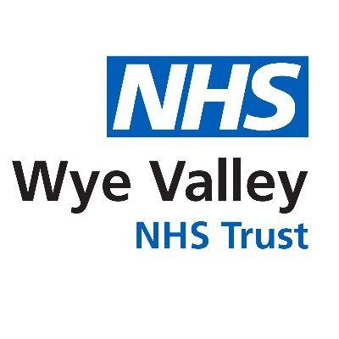

Cut it Out training on raising awareness of professionals about domestic abuse and how to help.
The #CutItOut initiative aims to raise awareness of the devastating impact of domestic abuse. Herefordshire Council and Herefordshire Community Safety Partnership are offering fully funded Cut it Out training to professionals who have a unique, one on one trusting relationship with clients.
The free training sessions are scheduled to take place in Ledbury, Leominster and Hereford. You can find out more about what the training involves and the sessions available by visiting the Eventbrite page for Ledbury, the Leominster or the Hereford.

Calling All Knitters and Crocheters – Help Us Create Animals of Hope!
Please help us create some 'Animals of Hope' for a special event taking place on 2nd October, when the Baton of Hope comes to Hereford.
Each animal should be no taller than 30cm and will form part of our Under-5s 'Hunt for Hope' Trail, with animals hidden in various locations around Hereford for little ones to discover.
To make these animals even more special, each one will carry a note of hope written by a local primary school child.
Whether you're an experienced maker or just enjoy crafting for a good cause, we’d love your support in spreading a little hope, joy and creativity throughout our community.
For more information about Animals of Hope please contact healthytots@herefordshire.gov.uk
Read more about the Baton of Hope, including the full event details, on the Talk Community Directory.

What's new on the directory?
Summer’s in full swing and so are our latest additions! From action-packed football camps to a heartwarming community day, creative family play sessions, and even coffee and chats with your local officers, there’s plenty to get out and enjoy across Herefordshire.
Toros FC Football Summer Camps
C.A.R.E Community Day in Aid of The Little Princess Trust
Play in the Borders – Play Therapy for children and families
Coffee with a Cop
Our socials are a great way to keep in touch with what’s on too, whether you’re
- a Facebook fan
- tuned in to Twitter
- or instantly on Instagram.
Have you heard of Shared Lives?
Our Lives get better when they’re shared
Herefordshire Shared Lives is a Care Quality Commission (CQC) registered service provided by Herefordshire Council. Shared Lives is a highly personalised form of care that supports people
