

Newsletter
21 March 2024

Fun, free activities for the family this Easter (and beyond)
Through our Winter of Wellbeing (WoW) grant, organisations across Herefordshire are holding fun and free activities for families throughout the Easter holidays (and beyond!).
There’s something for everyone, from roller-skating to ceramics, cookery fun, crafting and even an opportunity to meet the animals at Pentre Farm. The good news is that everyone is welcome and all sessions include free hot food and drinks for all attendees. Families will also be able to access information and advice to support them around the cost of living.
For information about the different activities taking place, visit the WoW page on the Talk Community Directory. Please do keep checking the page as it is regularly updated with new events, as the sessions continue into the spring.
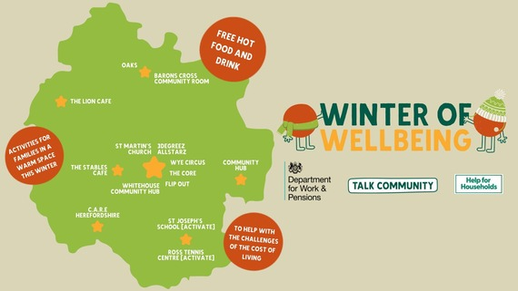

Debt Awareness Week
This week is Debt Awareness Week – an annual event led by the UK's leading provider of free debt advice, StepChange.
Debt Awareness Week 2024 is focusing on the ‘barriers to debt advice’, in the hope of encouraging as many people as possible to access the support they need as early as possible.
As the cost of living crisis continues, it’s more important than ever to break the stigma around getting debt advice and for those who are experiencing financial difficulty, to access the help that is available.
StepChange offer free, flexible debt advice and a range of debt solutions and tools to best support your situation. Visit the Talk Community website to find out about the local and national organisations who can help if you’re in debt or need additional assistance to manage your money.
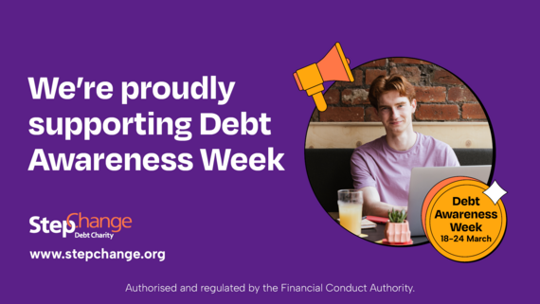

Stop Loan Sharks training seminars - new sessions available!
Would you be able to spot a loan shark or help someone report one in your community? With the cost of living crisis, it’s increasingly concerning that people might turn to illegal lenders to make ends meet.
Due to popular demand, Stop Loan Sharks are running more of their free online training sessions to show what they do and how we can all work together to help victims of illegal money lenders.
The live, trainer-led sessions last for an hour and there are some places still available to book throughout the coming months, but they are getting booked up quickly. For further details, visit the Talk Community Directory website.


Household Support Fund
The Household Support Fund, funded by the Department of Work and Pensions continues to offer support to households that are most in need.
To learn more about the Household Support Fund, eligibility, and application details, visit the Herefordshire Council website.
For more information and advice around the Cost of Living, visit the Money on Your Mind pages of the Talk Community website.

Food Waste Action Week (choose what you’ll use)
Love Food Hate Waste’s annual campaign Food Waste Action Week is back.
This year we are being encouraged to ‘choose what you’ll use’ by buying your fruit and vegetables loose instead of packaged. Research from Love Food Hate Waste has shown that we could reduce food waste by 60,000 tonnes just by buying loose fruit and veg!
With food waste costing £1,000 for an average household of four every year, Food Waste Action Week aims to help shoppers save money and waste less by shopping for loose produce. Sometimes we are in the mood for a huge potato, and sometimes we just need one carrot for our spag bol. Why let the rest go to waste? Choose loose and you don’t have to.
Visit the Love Food Hate Waste website to get tips on how to buy, prep and store food so it doesn’t go to waste.


Free online courses for parents, carers, grandparents and teens in Herefordshire
We hope you and your family get some quality time this Easter break. You might find a short online module on emotional health helpful in understanding your child’s development. Go to www.inourplace.co.uk and use the code APPLEHERE for free access.”


Recruiting staff for May's election
Herefordshire Council’s Election team are on the lookout for staff for the forthcoming Police and Crime Commissioners Elections in May 2024. To find out more about the roles on offer and how to apply, please visit the Herefordshire Council website.


What’s new on the Talk Community Directory?
Drop onto the directory to take a look at our newest additions, from family friendly board gaming events, free courses to help families going through a separation and drop in sessions for anyone interested in becoming a foster carer. Explore our egg-citing Easter activities activities list for ideas of how to keep the kids entertained over the holidays.
Fostering info drop in events: April, May, June
Here for Games Con - A free inclusive charity games convention
Herefordshire Board Gamers Big Event - free family charity event
Sibling group leader training
Family transitions Triple P courses - online course and Hereford city.

Our socials are a great way to keep in touch with what’s on too, whether you’re:
- a Facebook fan
- tuned in to Twitter
- or instantly on Instagram.

Herefordshire Cares Do you want to make a difference to people's lives every day? Working in social care is a rewarding career – to find out more about a career in adult social care, visit the Herefordshire Cares website.


For more updates, follow us on Facebook, Twitter and Instagram.
If you do not wish to receive emails from Talk Community, you can unsubscribe.
Alternatively, please email talkcommunityengagement@herefordshire.gov.uk

GovDelivery, sending to pcclerk@lintonpc-herefordshire.gov.uk on behalf of:  Herefordshire Council  Plough Lane, Hereford HR4 0LE · (01432) 260000 | 

